Collecting Landing Pages by Source/Medium data (1st Week January, 2023)

Website/SEO Assignments

NAME: Tahiya Rahman

horizontal line

# About the Data

The purpose of the paper is to find out the potential landing pages which are generating more leads, has the highest leads and has the probability to contribute to the increment in future with NSTEM website. The data depicts NSTEM’s potential lead generator site through users acquisition, behavior and a decent conversion. Also the users from each day's data shows a peak and a drop, which can be the best reason to investigate and find out the reason for the highest peak and the lowest drop for NSTEM website audience.

# Comparison of Data over Different Time Periods

Jan 1, 2023-Jan 8, 2023

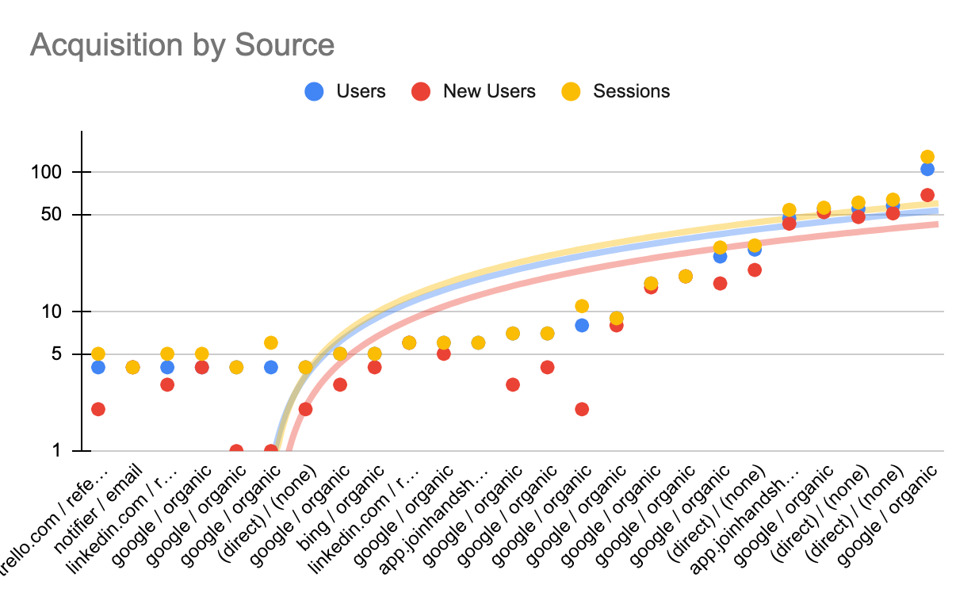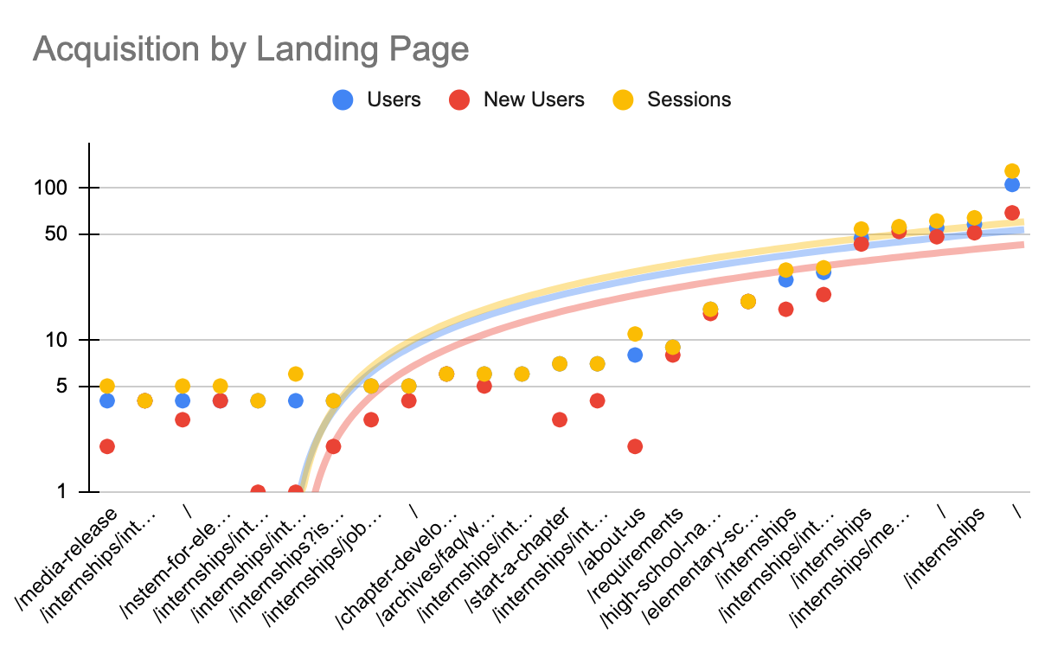

* As the data shown above, by acquisition the highest traffic catcher are from **google organic searches** and secondly the **app, handshake** from the source/medium.
* From landing page data, the highest traffic generators are mostly from the **internship opportunity** from NSTEM. The second highest traffic drivers are **elementary school and the chapters**.

Compared with December 2022 data

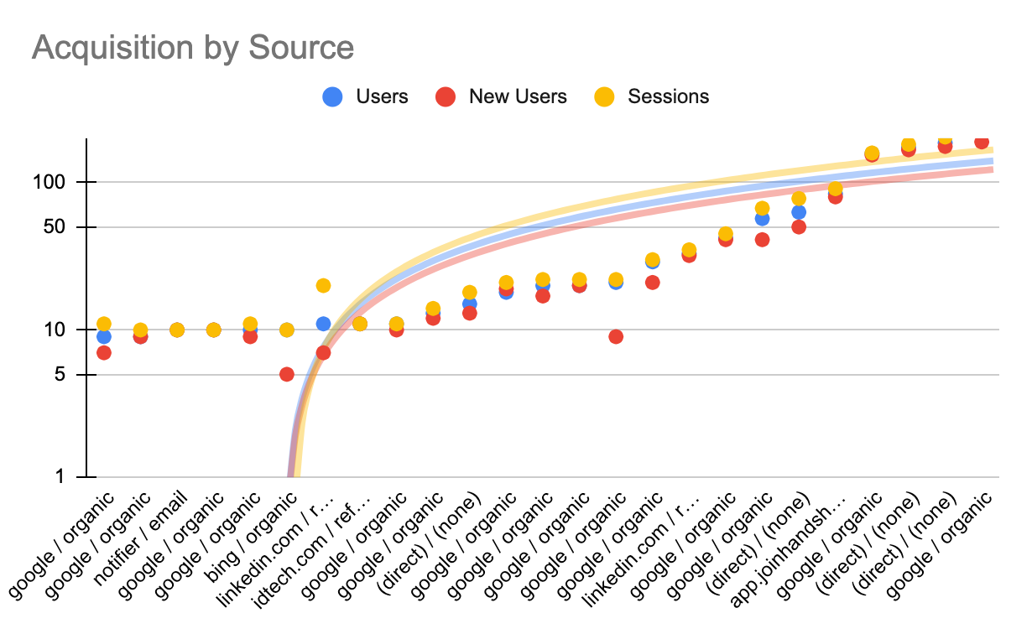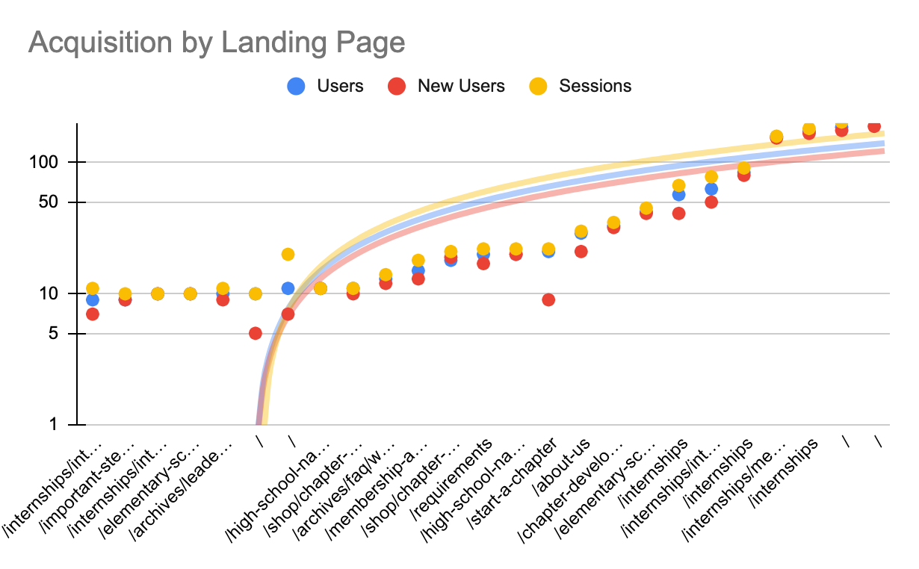

* There were no significant changes in the data from December 2022 to January 2023.
* Only **Linkedin and bing searches** are shown as a minimum lead generator which can be considered as a potential scope in future.

Jan 1, 2023-Jan 8, 2023

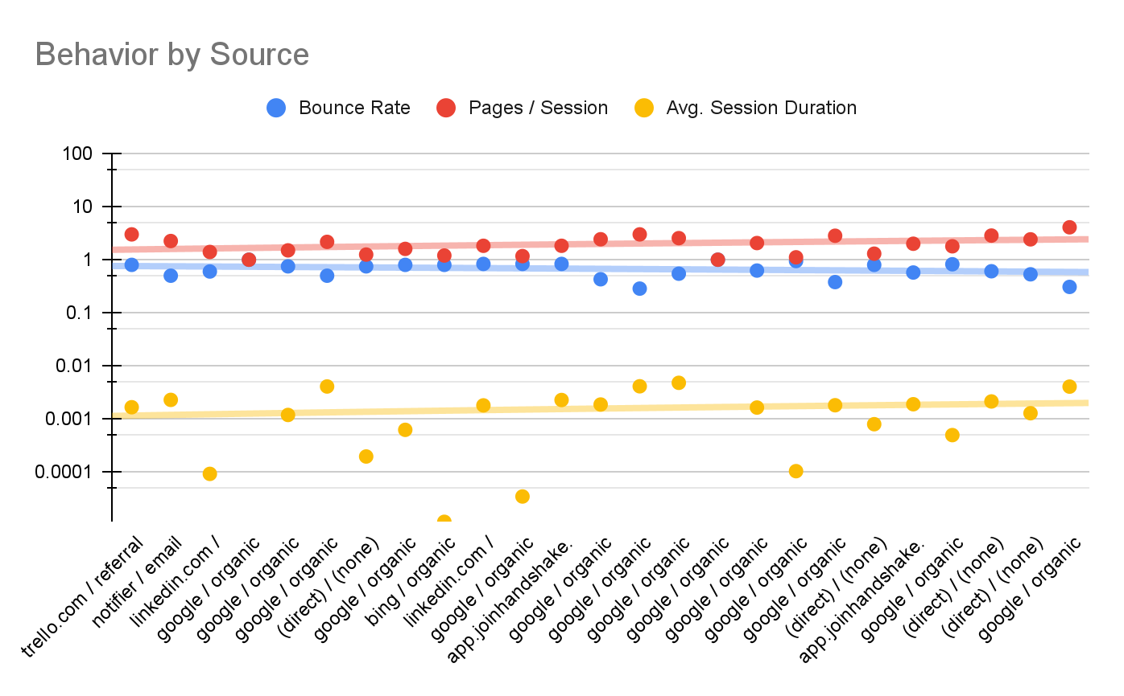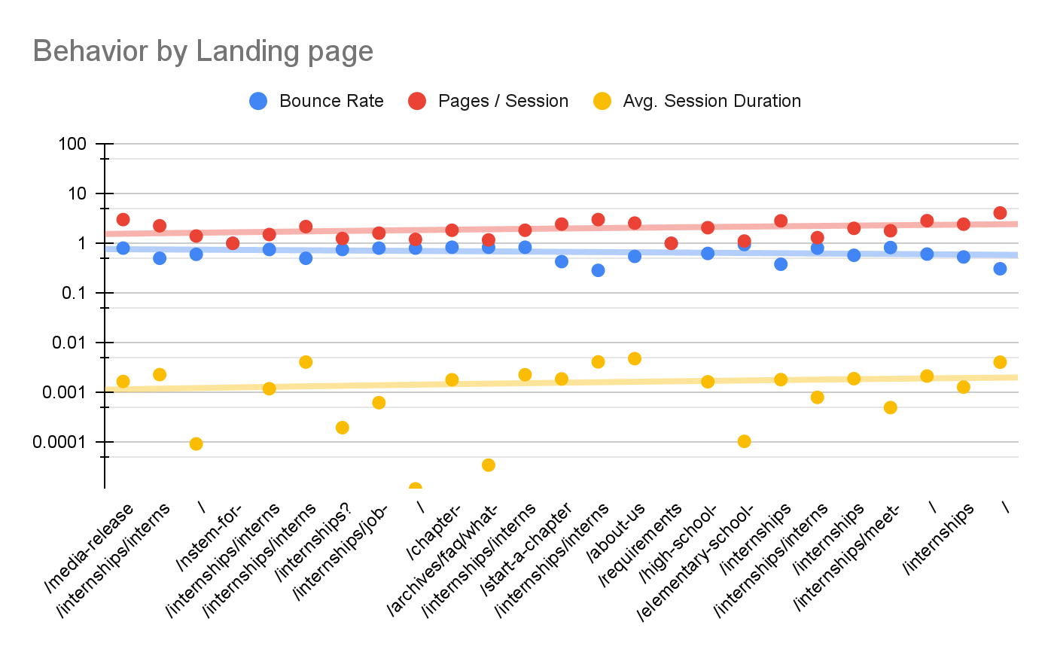

* All the data from bounce rate, pages/session and average session duration has been converted to 0.0000 in a decimal value.
* As shown in the data, the bounce rate and session per page is at a steady state. Thh trendline shows at its minimum.

Compared with December 2022 data

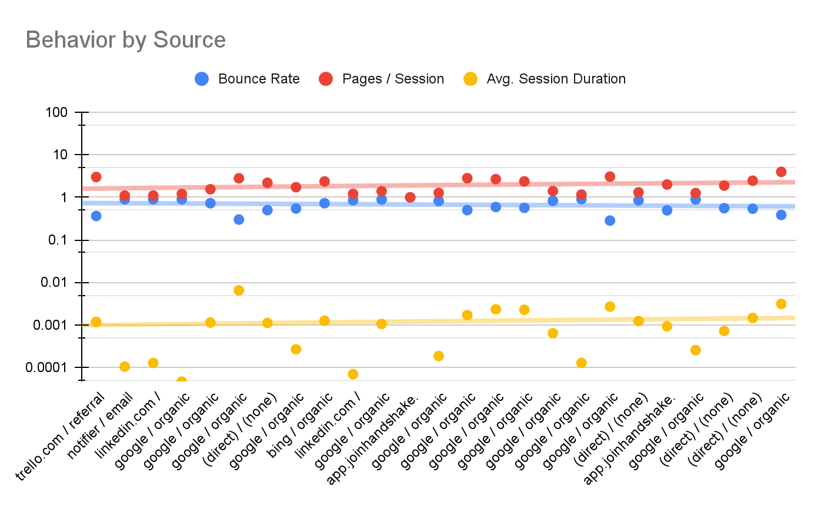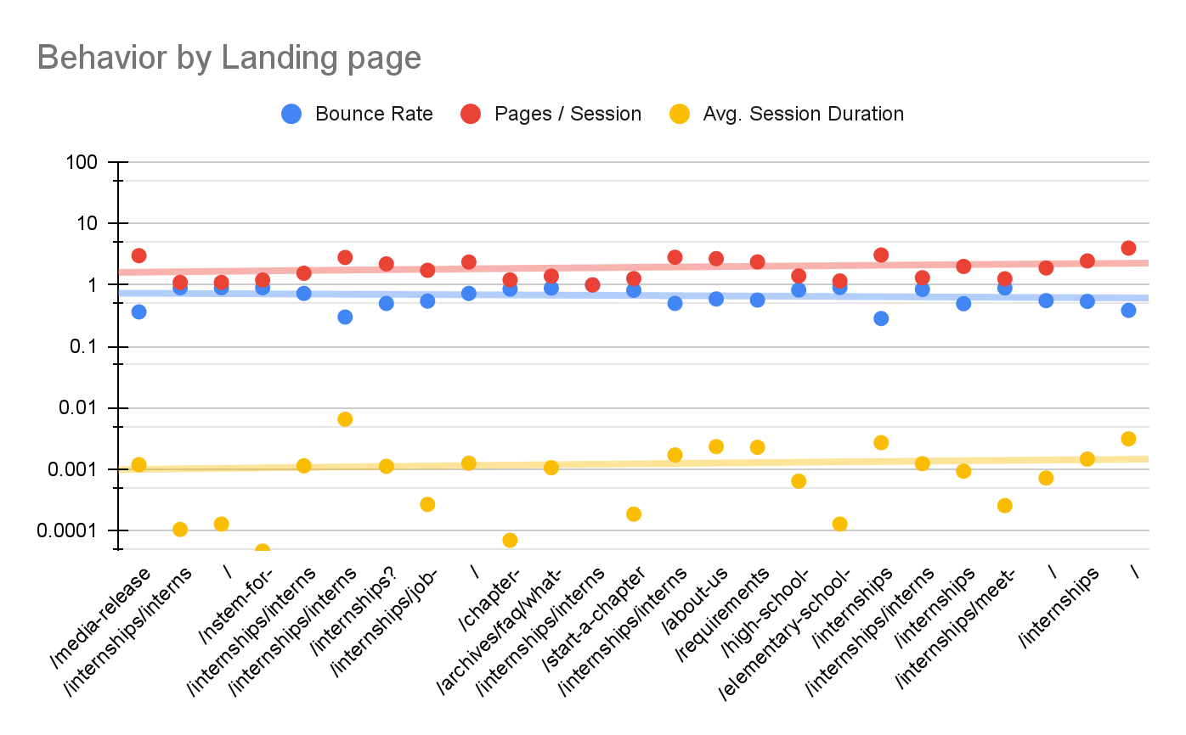

* The average session duration data, above the trendline were **trello.com/referral, google organic search, notifier email, linkedin.com, app join handshake** are the best source/medium can be considered as drivers.

Jan 1, 2023-Jan 8, 2023

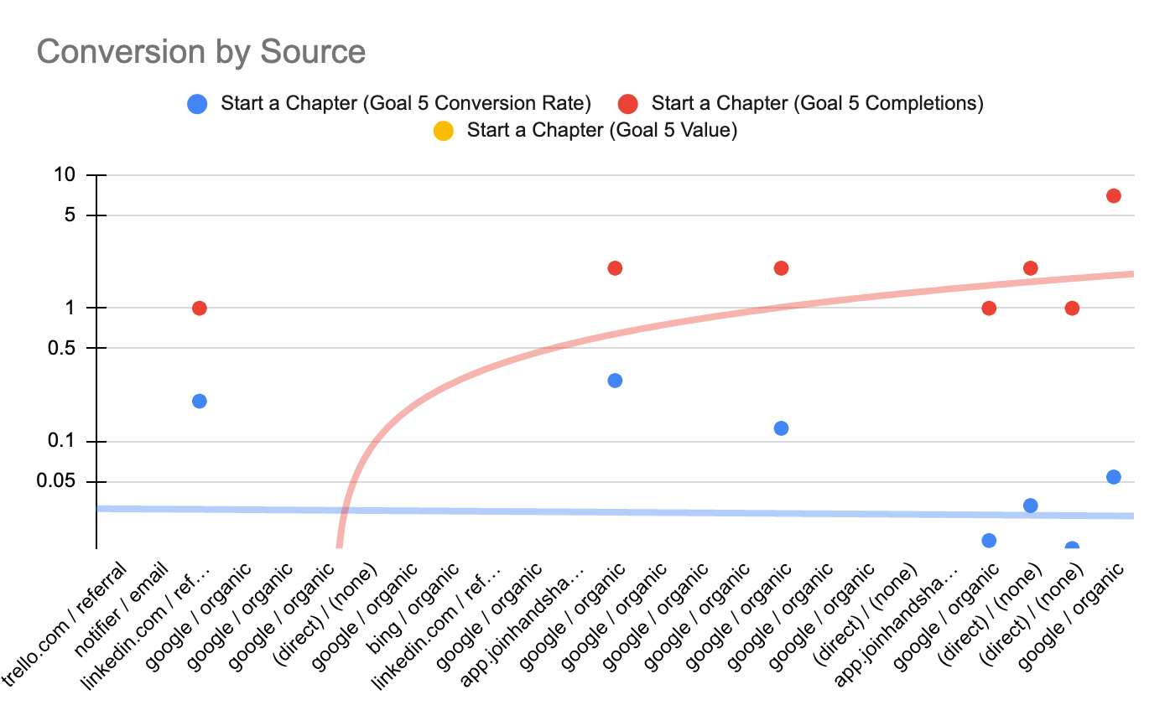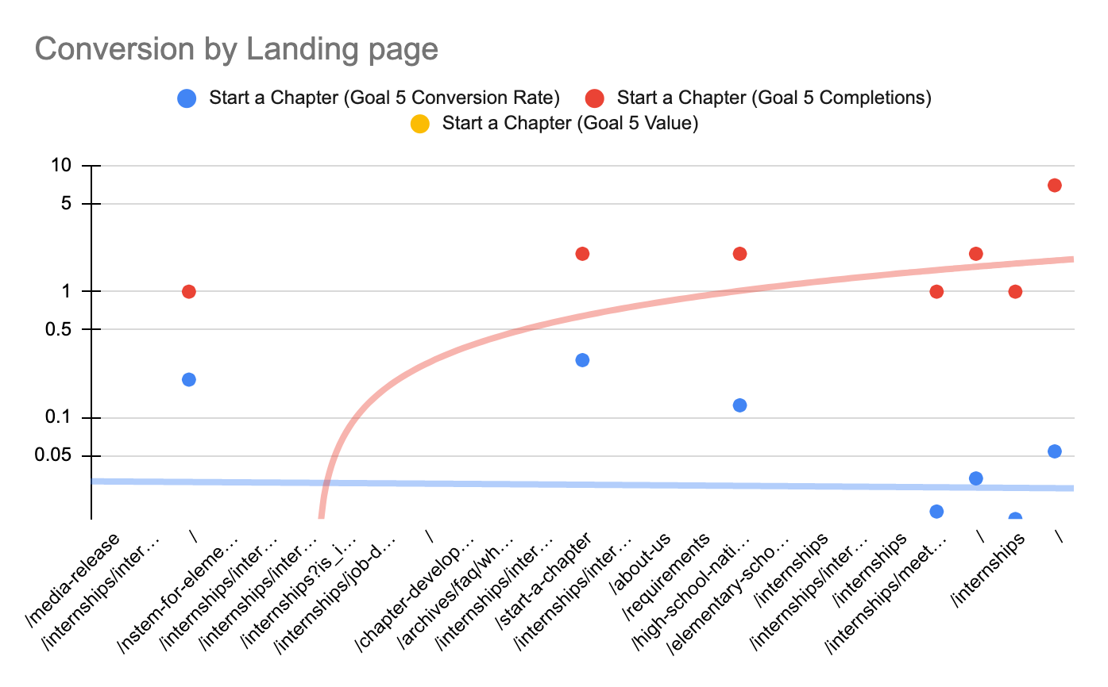

Compared with December 2022 data

* Most of the data are in the outliers and dots showing a disconnection between conversion rate and source/medium or landing page. Still there are some drivers that can be considered as a potential source.
* Besides, **google organic searches, Linkedin referrals** along with the **internship opportunities** the conversion depicts a decent conversion rate.

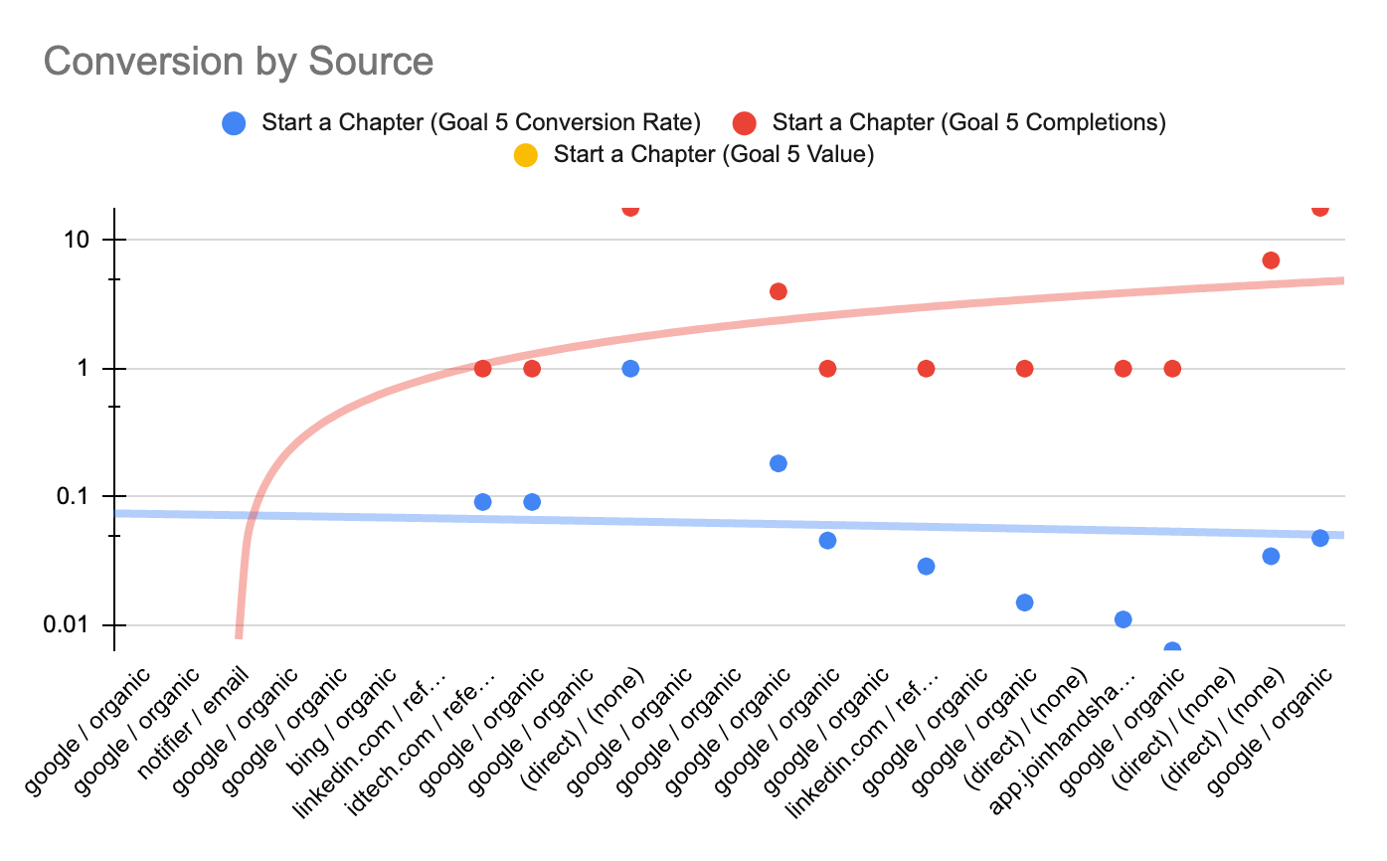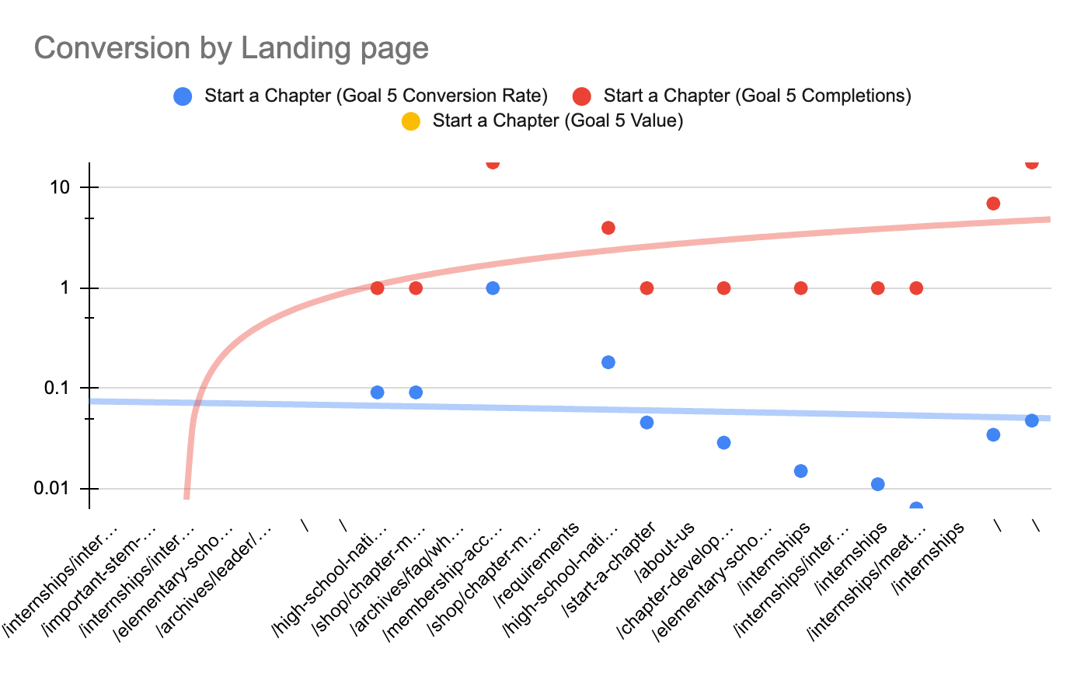

* A potential conversion should not have so many outliers and below the trendline. One of the conversion factors **Start a Chapter (Goal 5 Value)** has not been covered in the scatter plot because it was even below 0.00. So the completion and conversion rate was only the drivers able to reach the trendline threshold.

# Users by days

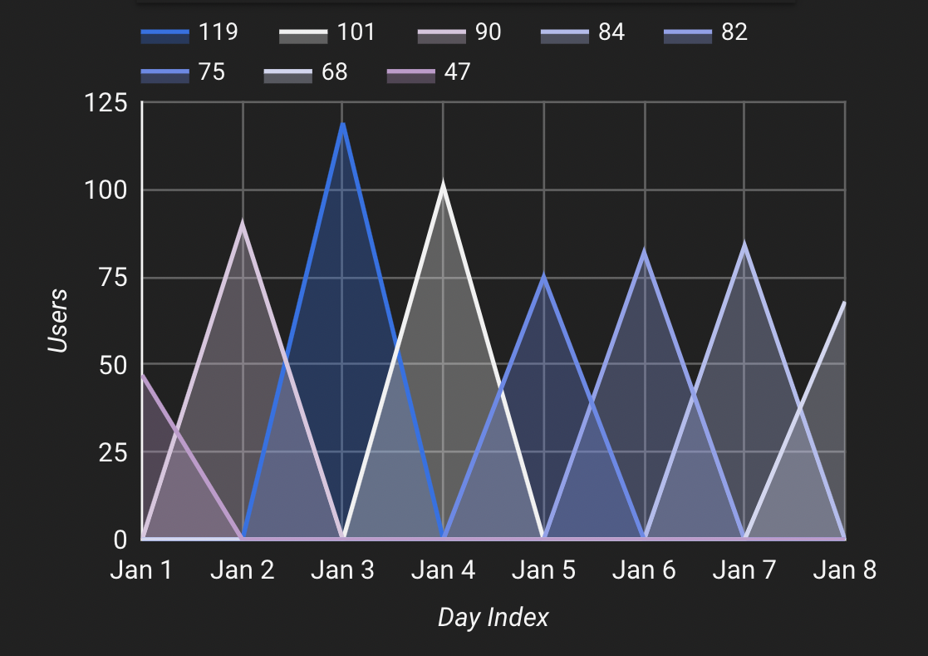 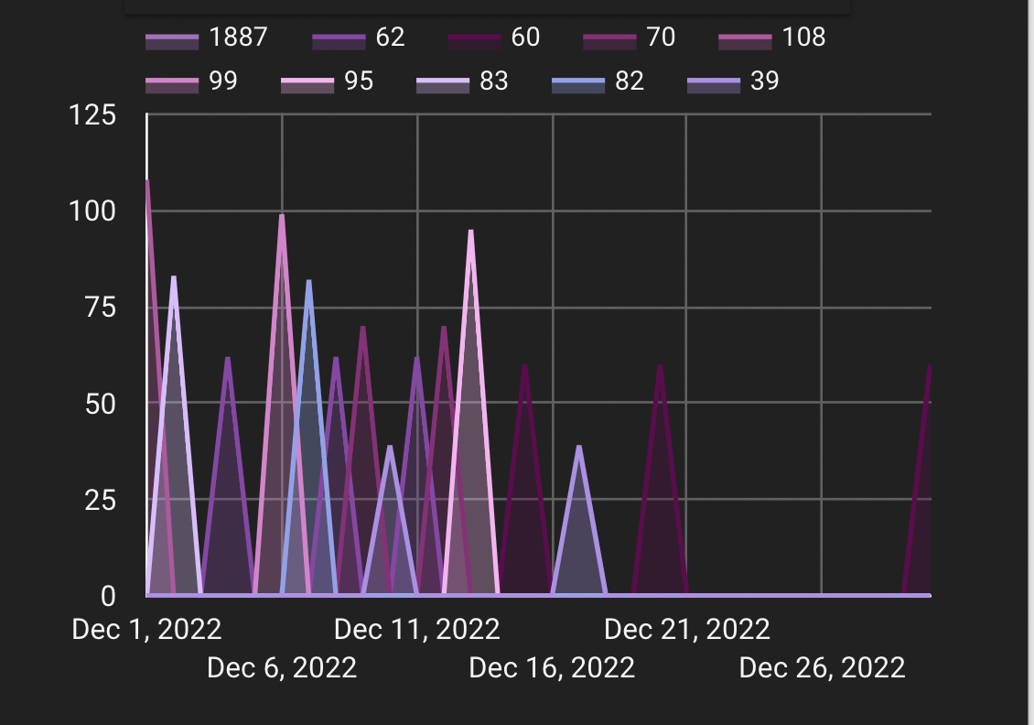

* From the Day index of January 2023, most traffic was generated on 3rd January. On the other hand, December 1st, December 6th and December 13th sequentially got the highest conversion.
* It seems like the first week of the month students like to seek opportunities for internships and referrals like Linkedin recruiters start to refer more.

# What NSTEM Should Continue Doing

* NSTEM should continue to get exposed by linkedin to increase the employment opportunities and chapter education.
* NSTEM should create an update or a real time tracker, chat assistance for the Handshake app for the internship seeking students. So it can get a credibility score from the institutions and form the students.

# Ways to Improve the Website

* NSTEM can introduce the use of GA4 Analytics, which can be used in chapter merchandise sites.
* Create more scope in data science, such as doing A/B testing for the website.
* Create a real time session portal, where administrators can access the portal and get information about the audience base.
* Ads optimization through facebook, pinterest and other social media.

# Data that Stands Out

From the analysis, the data from previous month to January 1st week shows a correlation between source medium and the lansing page. The same source medium was crowding towards the same type of landing pages. Most of the crowds were generated from organic searches and the traffic showed interest towards NSTEM internships and lastly the chapters.

# Conclusion

To conclude, the most potential source/medium and the traffic source was from the internship sites in NSTEM, chapter completion and the referrals from Linkedin.

Google Sheets: <https://docs.google.com/spreadsheets/d/17e9KPGovXXouL2I7Jbge_PEdCf-pf2KO66Id0jOFDyQ/edit?usp=sharing>

Google data studio: <https://datastudio.google.com/reporting/cc3a952b-1430-48cb-9d93-8022bd2bfe31>